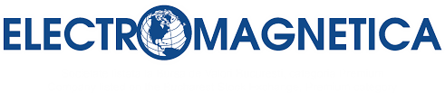  SUSTAINABILITY REPORT  for 2020 | 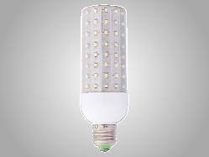  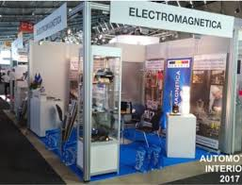  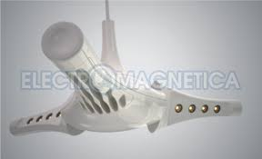  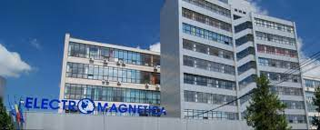      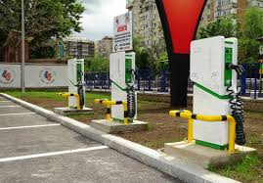  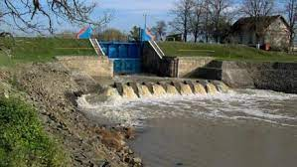
“ELECTROMAGNETICA
HAS LOOKED AND WILL LOOK INTO THE FUTURE!”

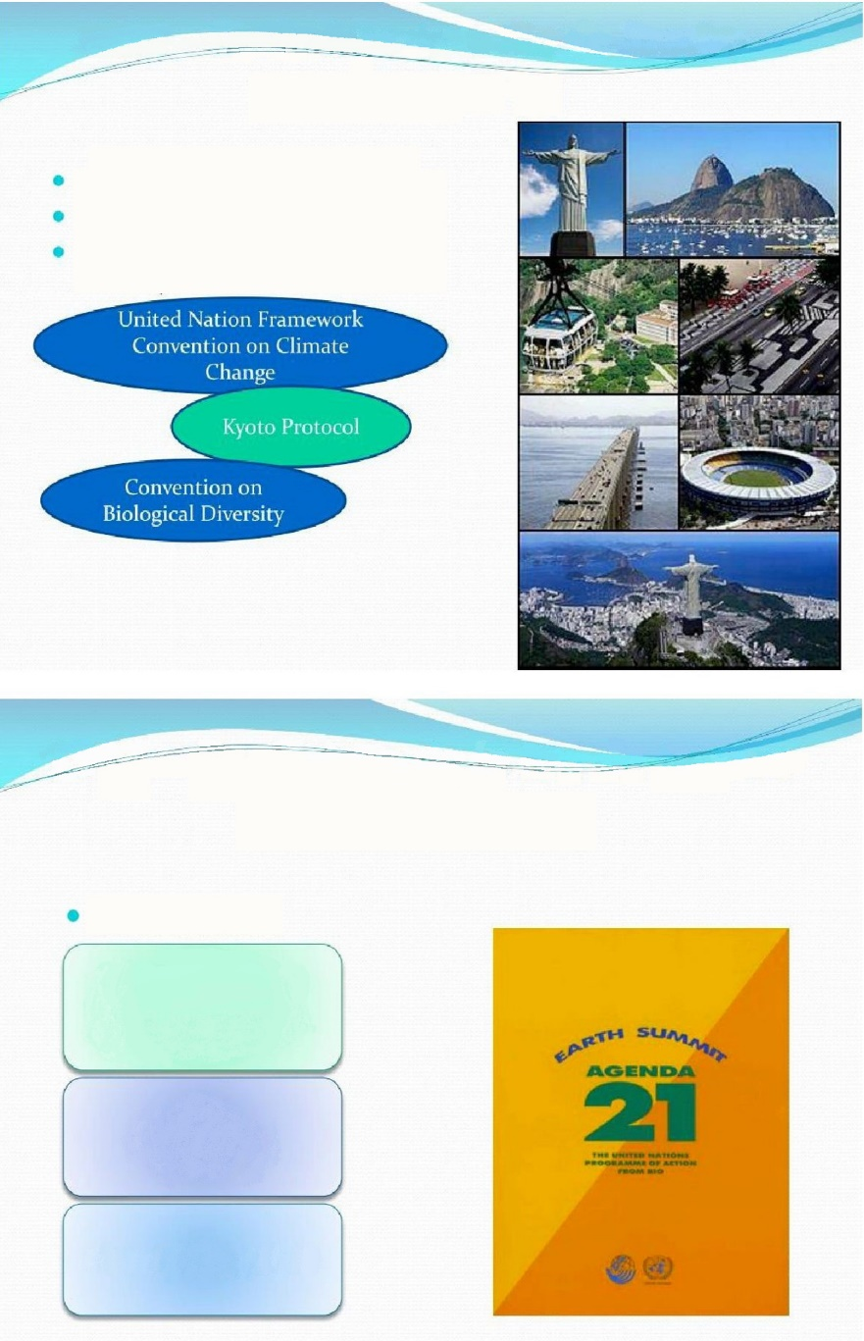  1992 – Rio de Janeiro Conference  Earth Summit (1)  1992 – Rio de Janeiro Conference  Earth Summit (2)  144 heads of states and governments  2,400 NGO representatives  17,000 participants (Global Forum)  Documents  Rio Declaration on Environment and Development  Agenda 21  Forest Principles | Extract from the Rio Declaration on Environment and Development  United Nations Conference on Environment and Development, 3-14 June 1992, Rio de Janeiro, Brazil  ● First principle: Human beings are at the centre of concerns for sustainable development. They are entitled to a healthy and productive life in harmony with nature.  ● Second principle: States have, in accordance with the Charter of the United Nations and the principles of international law, the sovereign right to exploit their own resources pursuant to their own environmental and developmental policies, and the responsibility to ensure that activities within their jurisdiction or control do not cause damage to the environment of other States or of areas beyond the limits of national jurisdiction  ● Third principle: The right to development must be fulfilled so as to equitably meet developmental and environmental needs of present and future generations.  ● Fourth principle: In order to achieve sustainable development, environmental protection shall constitute an integral part of the development process and cannot be considered in isolation from it.  ● Fifth principle: All States and all people shall co-operate in the essential task of eradicating poverty as an indispensable requirement for sustainable development, in order to decrease the disparities in standards of living and better meet the needs of the majority of the people of the world.

 | CONTENTS
I. | Message from the General Director
II. | Sustainability
 | II.1. | Definitions
 | II.2. | Legislation
 | II.3. | Evolution and trends
 | II.4. | About the Sustainability Report
III. | Who we are – A presentation of ELECTROMAGNETICA
 | III.1. | General data
 | III.2. | History; 90 years of continuity
 | III.3. | Corporate governance
 | III.4. | Activity; markets served
 | III.5. | Mission, vision, values
 | III.6. | ELECTROMAGNETICA SA in figures - 2020 -
 | III.6. | III.6.a. | Financial data
 | III.6. | III.6.b. | Data on employees
 | III.6. | III.6.c. | Data on economic activity
IV. | The vision of ELECTROMAGNETICA SA on sustainability and sustainable development
V. | Risk management in priority areas
 | V.1. | Economic risks
 | V.2. | Social risks
 | V.3. | Environmental risks
 | V.4. | Risks covered by insurance policies
VI. | Partnerships by which we aim to develop our capacity to tackle the present and future challenges in terms of business sustainability and sustainable development.
VII. | Conclusions

I. MESSAGE FROM THE GENERAL DIRECTOR
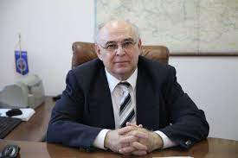
“Business ethics is the foundation of our commercial relationships, characterized by honesty, integrity, mutual trust and social responsibility.

We always act in accordance with the law and fairly in our relationships with partners and stakeholders. We do not accept corruption, evasion, monopolization or intimidation.

We operate in markets where competition is strong. We consider this competition to be beneficial, but it must be fair and obey the rules on free competition.

Our success, proven by our longevity that extends for over 90 years – almost a century of history – comes from our attitude: we have looked and will look into the future! We apply a horizontal integration business strategy, focused on a diverse portfolio of activities. This strategy was dominant in 2020 and we intend to maintain it in the future, on the short, medium and long term. To remain competitive and ensure business sustainability, we aim at optimising our chain of research – development – production – sales.

Sustainable development is among our main concerns and our first priority is PEOPLE as employees and representatives of our company, who have the power to influence the success and reputation of ELECTROMAGNETICA SA. Our purpose is to build and ensure a working environment focused on integrity, professionalism, motivation and satisfaction.

In line with the globally recognised importance of environmental factors, we produce green energy in our micro-hydro power plants and we encourage the efficient use of energy by delivering charging stations for electric vehicles.

We are pleased that we have the opportunity to present to all the interested parties the Sustainability Report of ELECTROMAGNETICA SA for 2020, with openness and transparency, self-confidence and trust in our investors”.

General Director
Eugen SCHEUSAN

II. SUSTAINABILITY

II.1. Definitions


sustainability: the ability of an anthropic activity to be carried out without exhausting available resources and without destroying the environment, thus without compromising the possibilities of meeting the needs of future generations.
PLANET
SUSTAINABILITY
The Rio de Janeiro World Conference on the Environment in 1992 paid particular attention to this concept, which involves striking a balance between economic growth and environmental protection and finding alternative resources. When referring to overall economic development, the synonymous term sustainable development is preferred.
POPULATION
PROFIT

sustainable development: the 1987 Brundtland Report of the World Commission on Environment and Development, entitled “Our Common Future”, defined sustainable development as “the development that meets the needs of the present without compromising the ability of future generations to meet their own needs.”. Its aim is to reconcile economic development and the protection of social and environmental balance.
In 2001, the EU adopted a strategy for sustainable development. It was revised in 2006, providing a “long-term vision of sustainability in which growth, social cohesion and environmental protection go hand in hand and support each other”.
The analysis of this strategy, made by the European Commission in 2009, highlighted the persistence of unsustainable trends and the need for greater efforts regarding these. However, the Commission noted the progress made by the EU in integrating sustainable development into many of its policies (including the trade and development policies) and highlighted the Union's leadership on climate change and the promotion of a low-carbon economy.

Sustainable development has officially become one of the European Union's long-term objectives under Article 3(3) of the Treaty on European Union.

II.2. Legislation
- Directive 2013/34/EU of the European Parliament and of the Council on the annual financial statements, consolidated financial statements and related reports of certain types of undertakings, amending Directive 2006/43/EC of the European Parliament and of the Council and repealing Council Directives 78/660/EEC and 83/349/EEC
- Directive 2014/95/EU of the European Parliament and of the Council of 22 October 2014 amending Directive 2013/34/EU as regards the presentation of non-financial and diversity information by certain large undertakings and groups, published in the Official Journal of the European Union, L series, no 330 of 15 November 2014
- Order no. 1938/2016 of the Minister of Public Finance of 17 August 2016 amending and supplementing certain accounting regulations

II.3. Evolution and trends

Launched 30 years ago, in response to environmental problems, at the Stockholm Conference on the Environment of 1972, the concept of sustainable development evolved continuously until 1983, when the World Commission on Environment and Development (WCED) began its activity, following a resolution adopted by the United Nations General Assembly, and in 1987, one year after the Chernobyl disaster, the most quoted definition of sustainable development was formulated in the WCED Brundtland Report: “Sustainable development is the development that meets the needs of the present without compromising the ability of future generations to meet their own needs”.
The term sustainable development became widely known after the United Nations Conference on Environment and Development in Rio de Janeiro, known as the “Earth Summit”, took place in the summer of 1992. Sustainable development became an objective of the European Union in 1997, when it was incorporated into the Maastricht Treaty, and in 2001, the EU Sustainable Development Strategy was adopted at the Goteborg Summit and was added an external dimension at Barcelona in 2002.
The European Commission announced on 21 April 2021 an ambitious and comprehensive package of measures to promote sustainability as part of the objective of creating a climate-neutral Europe by 2050. One of the measures is a proposal for a directive on corporate sustainability reporting, the aim of which is to improve the flow of information about sustainability in the corporate world so that companies, investors and the general public can use comparable and relevant information in the decision-making process.
The Directive imposes additional reporting requirements compared to the current rules of the Non-Financial Reporting Directive (NFRD), with the aim of making sustainability reporting comparable to financial reporting in the long term.
The European Commission aims to make the reporting of sustainability impacts and risks mandatory by the companies that will be covered by this Directive as of 2023, based on a European standard.

In this context, there is a concern to align with these trends and to transpose European actions in order to help national companies improve their sustainability performance and to highlight these actions in the corporate sustainability reporting.
In the decision-making process, environmental, social and governance factors are growing in importance, either as cost-effectiveness factors, or as risk mitigating factors.
In concrete terms, the Romanian Investor Relations Association - ARIR - has developed in collaboration with INNOVA Project Consulting a Guide on Sustainability, through which it intends to support all Romanian companies that want to improve their performance in this field. The strategic partner of this project is the Bucharest Stock Exchange.

It should be mentioned that ELECTROMAGNETICA SA is a founding member of ARIR. As founding member of ARIR, ELECTROMAGNETICA SA participated actively in the meetings and conferences organized by the Association (including meetings with the ASF), thus seeking to improve its methods of communication with investors, as well as to be informed on the legislative changes anticipated on the capital market (European regulations and Romanian draft legislation).
According to the VEKTOR methodology, which quantifies the methods of communication with investors, created by ARIR together with BVB, our company managed to increase its score by almost 3 times as compared to the previous year.
Other ARIR members are Banca Transilvania, Hidroelectrica, Nuclearelectrica, Transelectrica, ALRO, BVB, Franklin Templeton Management.

III. WHO WE ARE; A PRESENTATION OF ELECTROMAGNETICA

III. 1. General data

ELECTROMAGNETICA SA is an entirely privately owned legal entity, listed on the Bucharest Stock Exchange, Premium category, having its registered office in Bucharest, Sector 5, Calea Rahovei 266-268, Sole Registration Number (CUI) RO 414118, registered with the Trade Register under no. J40/19/1991.
ELECTROMAGNETICA SA is recognised as a traditional producer and supplier of equipment for the distribution and measurement of electric energy, LED lighting solutions, electrical and electronic subassemblies, metallic and plastic injection moulded subassemblies, tools and moulds, automotive subassemblies, railway traffic safety systems. At the same time, it is oriented to the production of green energy and the development of energy efficiency increasing technologies.

III. 2. History; 90 years of continuity

1930 | Founded under the name “Standard Electrica Romana”, the company develops the first telephone sets and telephone exchanges in Romania.
1948 | The company completes its activity by manufacturing electric meters and electromagnetic measuring instruments.
1959 | The scope of activity is extended by automation equipment for railway infrastructure, rectifiers, relays.
1962 | In accordance with its main activity, the company is named ELECTROMAGNETICA.
1968 | Crossbar-Pentaconta automatic telephone exchanges begin to be manufactured.
1990 | ELECTROMAGNETICA becomes a joint-stock company.
1996 | ELECTROMAGNETICA starts manufacturing automotive subassemblies and implements the Quality Management System, thus becoming the fifth company in Romania certified by AEROQ.
1997 | The company shares are listed on the RASDAQ stock exchange; the manufacture of telecommunication shelters is launched.
1998 | The company starts to develop equipment for electric power supply and distribution, including the new generation of electronic meters. ELECTROMAGNETICA is certified by RENEL as supplier of products and services for its subsidiaries.
1999 | ELECTROMAGNETICA becomes a private company. The company obtains the first Product Marketing Authorizations issued by SC ELECTRICA SA.
2000 | ELECTROMAGNETICA becomes a supplier of products and services approved by the companies HIDROELECTRICA, TERMOELECTRICA, TRANSELECTRICA.
2001 | Upon the opening of the electricity market, ELECTROMAGNETICA obtains the licence for electricity supply from ANRE. The company’s certification as supplier of products and services is renewed by SC ELECTRICA SA.
2002 | ELECTROMAGNETICA starts the supply of electricity to customers declared eligible by ANRE.
2003 | ELECTROMAGNETICA continues the development of investments in mould production technologies and plastic injection equipment.
2004 | The company implements the Environmental Management System.
2005 | The Centralized System for Remote Reading and Management of Residential Electric Meter Data “ENERGSys” is implemented for household electricity consumers.
2006 | ELECTROMAGNETICA is licensed as producer of electricity from renewable sources.  The company acquires micro-hydro power plants for electricity generation.
2008 | The program of investments in micro-hydro power plants is launched with the aim to modernise, upgrade and expand production capacities.
2010 | ELECTROMAGNETICA designs and produces the first LED lighting devices, a new technology that leads to power savings. Completion of SHPP Brodina de Jos construction – new objective.
2011 | Completion of SHPP Brodina 2 construction – new objective.  Listing of company shares to first tier of BVB.
2013 | Completion of the program of investments in micro-hydro power plants, started in 2008.
2015 | ELECTROMAGNETICA purchased two new numerically-controlled machines for the manufacture of tools and moulds.
2017 | ELECTROMAGNETICA designs and produces the first charging stations for electric vehicles.
2020 | ELECTROMAGNETICA designs and produces fast charging stations for electric vehicles  ELECTROMAGNETICA develops ELMotion – management software for electric vehicle charging stations  ELECTROMAGNETICA designs and produces the AQUILLA lighting fixture that ensures the best lighting for stadiums, airports and large areas. The company executes the night-time lighting system for the athletics arena in Craiova  ELECTROMAGNETICA obtains the international ENEC+ certification for the EVOCITIY street lighting fixtures

III. 3. Corporate Governance

ELECTROMAGNETICA SA is managed by:
a) The Board of Directors, composed of seven directors, temporary and revocable, elected by the General Meeting of Shareholders, the majority of the members of the Board of Directors being non-executive directors. They are elected for a period of 4 years, their current term of office ending on October 18, 2023.
b) The managing directors to whom the Board of Directors has delegated the management (within the meaning of Article 43*) of Law no. 31/1990, republished, as amended and supplemented) - four directors, the chairman of the Board of Directors being also the general director, under the mandate contracts which establish the duties and the remuneration (during the performance of mandates, the individual employment contracts of the directors appointed from among the employees are suspended).
c) The Audit Committee of the Board of Directors of ELECTROMAGNETICA SA, set up on 7 March 2018 under the Decision of the Board of Directors approved by the General Meeting of Shareholders held on 25 April 2018. The Audit Committee operates under the Regulation of the Audit Committee, approved by the Board of Directors on 10 August 2018. The Audit Committee is a standing committee with an advisory role, which assists the Board of Directors in performing its duties.
The Audit Committee is composed of: one chairperson, non-executive member of the Board of Directors, financial auditor, one non-executive member of the Board of Directors, one non-executive independent member, financial auditor, approved by the General Meeting of Shareholders held on 22 April 2018.
The members of the Audit Committee have been appointed taking into account their knowledge of the industry in which ELECTROMAGNETICA SA operates and their experience in accounting, auditing or risk management matters.

The company organization chart is presented below:
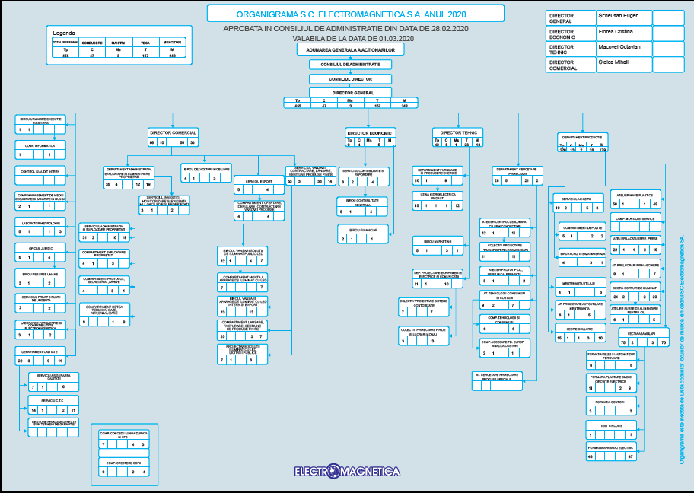

III. 4. Activity; markets served

ELECTROMAGNETICA is recognised as a traditional producer and supplier of equipment for the distribution and measurement of electric energy, LED lighting solutions, electrical and electronic subassemblies, metallic and plastic injection moulded subassemblies, tools and moulds, automotive subassemblies, railway traffic safety systems. At the same time, it is oriented to the production of green energy and the development of energy efficiency increasing technologies.
All products are made according to national and European standards and norms. The products are designed and developed by the company’s own research and design department and have a high degree of integration due to the variety of manufacturing technologies owned by the company.
Under the name ELECTROMAGNETICA BUSINESS PARK, the company offers rental services for surplus spaces, managing over 32,000 square meters of rental space at its headquarters in Bucharest, for offices, warehouses, manufacturing, services and conference rooms. The occupancy rate is over 93%.
The future development of the company is aimed at a mix of complementary activities that provide long-term stability and the development of related activities to make better use of existing resources.

III. 5. Mission, vision, values

The MISSION of ELECTROMAGNETICA’s senior management and employees is to provide high performance solutions based on new technologies, in order to fully satisfy customers and reasonably meet expectations by searching and opening new roads in the technical and business activities.

Our VISION in order to achieve our mission is to develop in particular products deriving from our own research-design activity. By its strategy, ELECTROMAGNETICA aims to expand to complementary fields, with a high potential for growth, which allow us to make better use of our research and development resources and our technological base.
At the same time, the company aims at maintaining a high degree of production flexibility, the full or partial outsourcing of mechanical processes at competitive costs, reinvesting profit, financing mainly from own sources, balanced diversification of activity and risk balancing.

The VALUES that define and model permanently the identity of our company and our organizational culture are:
• Creativity: we are innovative and we apply constantly the newest technologies and the most appropriate solutions;
• Business ethics: is the foundation of our commercial relationships, characterized by honesty, integrity, communication and mutual trust;
• Cooperation: we address proactively the needs of customers by offering them quality products and services that add value for long-term direct and indirect benefits;
• Accountability: we act responsibly to protect the environment, the safety, health and personal development of employees in order to create a fair and competitive business environment and to contribute to the social and cultural development of the community;
• Self-confidence: we believe that team work, together with our expertise and resources, ensure the strength required to achieve our mission and to secure the sustainable development of the company;
• Adaptability: we adapt permanently to market requirements, searching for and discovering new opportunities, while being constantly focused on the needs and expectations of customers.

III. 6. ELECTROMAGNETICA SA in figures - 2020 -

III. 6.a. Financial data

 | Note |  | 12-month period  ended on  31 December 2020 |  | 12-month period  ended on  31 December 2019
Revenues | 20 |  | 283,151,730 |  | 256,169,132
Investment income | 20 |  | 932.082 |  | 1,018,418
Other net revenues and expenses | 20 |  | 10,794,514 |  | 6,802,816
Variation in stocks of finished goods and work in progress | 20 |  | 7,934,317 |  | 13,389,266
Work performed by entity and capitalised | 20 |  | 1,481,686 |  | 772.403
Raw material and consumables used | 21 |  | (219,528,624) |  | (188,946,222)
Expenses related to employees | 24 |  | (30,490,094) |  | (36,494,887)
Expenses related to depreciation and impairment | 21 |  | (10,199,234) |  | (10,183,159)
Other expenses | 21 |  | (37,943,201) |  | (36,706,154)
Financial expenses | 22 |  | (3,947,166) |  | (840.410)
Profit before income tax |  |  | 2,186,009 |  | 4,981,203
Income tax | 23 |  | 138.292 |  | (492.516)
Profit for the period |  |  | 2,324,301 |  | 4,488,687
Other comprehensive income:
of which:
other comprehensive income items that cannot be reclassified in the profit and loss account, of which:
- Surplus from tangible assets revaluation |  |  | - |  | -
- Deferred tax recognized in equity | 23 |  | - |  | -
Deferred tax related to derecognised assets |  |  | 338 |  | 6.085
Comprehensive income for the period |  |  | 2,324,639 |  | 4,494,772
Basic/diluted earnings per share | 26 |  | 0.0034 |  | 0.0066

These interim separate financial statements were approved for disclosure by the management at 24 March 2021.

EUGEN SCHEUŞAN |  |  |  | CRISTINA FLOREA
Managing Director |  |  |  | Chief Financial Officer

 | Note |  | 31 December  2020 |  | 31 December  2019
ASSETS
Non-current assets
Tangible assets | 4 |  | 275,703,825 |  | 277,545,153
Real estate investments | 5 |  | 11,114,654 |  | 5,182,279
Intangible assets | 6 |  | 291.521 |  | 466.487
Investments in related entities | 8 |  | 841.408 |  | 3,967,606
Other long-term non-current assets | 9 |  | 19,804,010 |  | 24,702,276
Assets related to rights of use | 7 |  | 2,085,114 |  | 1,480,078
Total non-current assets |  |  | 309,840,532 |  | 313,343,879
Current assets
Inventories | 10 |  | 13,402,675 |  | 15,411,327
Trade receivables | 11 |  | 58,611,348 |  | 55,114,158
Cash and cash equivalents | 13 |  | 20,108,460 |  | 21,711,183
Other current assets | 12 |  | 1,882,350 |  | 1,939,785
Current tax debt | 23 |  | 949.937 |  | 760.012
Total current assets |  |  | 94,954,770 |  | 94,936,464
Total assets |  |  | 404,795,302 |  | 408,280,342
EQUITY AND LIABILITIES
Equity
Share capital | 14 |  | 67,603,870 |  | 67,603,870
Reserves and other equity components | 15 |  | 176,146,894 |  | 176,697,881
Retained result | 16 |  | 91,473,196 |  | 91,301,725
Total equity attributable to company shareholders |  |  | 335,223,960 |  | 335,603,476
Non-current liabilities
Trade payables and other liabilities | 19 |  | 1,168,772 |  | 1,265,003
Investment subsidies | 17 |  | 4,247,088 |  | 4,410,306
Deferred tax liabilities | 23 |  | 16,735,345 |  | 17,333,187
Leasing debts | 7 |  | 1,312,782 |  | 728.164
Total non-current liabilities |  |  | 23,463,987 |  | 23,736,660
Current liabilities
Trade payables and other liabilities | 19 |  | 42,982,576 |  | 46,268,240
Investment subsidies | 17 |  | 163.219 |  | 163.219
Provisions | 18 |  | 2,156,891 |  | 1,806,142
Current income tax liability | 23 |  | - |  | -
Leasing debts | 7 |  | 804.669 |  | 702.605
Total current liabilities |  |  | 46,107,356 |  | 48,940,206
Total liabilities |  |  | 69,571,343 |  | 72,676,866
Total equity and liabilities |  |  | 404,795,303 |  | 408,280,342

These interim separate financial statements were approved for disclosure by the management at 24 March 2021.

EUGEN SCHEUŞAN |  |  |  | CRISTINA FLOREA
Managing Director |  |  |  | Chief Financial Officer

SECURITIES MARKET
Share price evolution:
Electromagnetica is listed on the Bucharest Stock Exchange (BVB), Premium Category, where its shares are traded with the following characteristics:
Stock symbol: ELMA
Ordinary, registered, dematerialised shares
Number of issued shares: 676,038,704
Nominal value: RON 0.1000
Share capital: RON 67,603,870.40
ISIN Code ROELMAACNOR2
Code LEI: 254900MYW7D8IGEFRG38
ELMA shares are included in the BET Plus stock index.

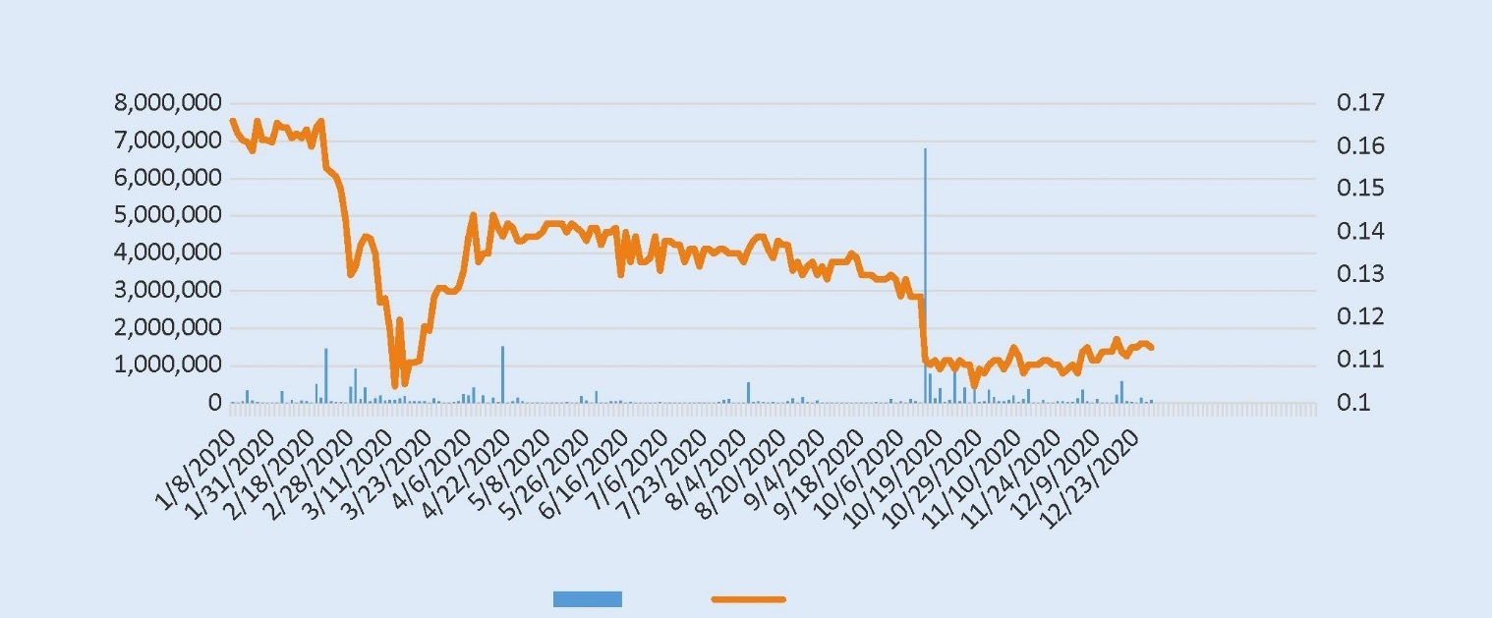
Volume
Price (lei)
ELMA shares evolution in 2020
Volume
Closing price
In 2020, there were traded shares representing 3.81% of the total number of shares, adding up to 4.69% of the Company share capital, for an average price of 0.1231 lei/share.
The reference price varied between minimum 0.1040 lei/share and maximum 0.1660/share. The closing price at the end of 2020 was 0.113 lei/share corresponding to a market capitalisation of 76,392,373.55 million lei.

III. 6. b. Data on employees

The high qualification level of employees enabled the Company to carry out both production and research and development activities.
In 2020, the average number of employees was 387, by 15 % lower than the average number of employees in the previous year. This decrease was due to natural causes (retirement) and to the fact that, for a period of 3 months, part of the employees had reduced working hours.
In 2020, against the background of a fall in orders, the company reduced its working hours to 4 days for 3 months, with a proportional reduction in revenues. In this way, the company succeeded to avoid layoffs and to retain its qualified employees. For the same purpose, company employees about to retire for old age were given the opportunity to continue their activity within the company
Among the employees, there are 30 % employees with higher education and 35 % with secondary education The company employees follow a continuous professional training program, each employee benefiting from average of 25 hours/year of professional training or internal and external training on quality, occupational health and safety, environment, etc.
The relationships between the company management and employees are conducted under normal conditions. The Union membership rate is about 73% and there have been no labour conflicts between the employer and the trade union.

III. 6.c Data on economic activity
In 2020, the company’s economic activity focused on the following segments:

► PRODUCTS AND SERVICES AIMED AT INCREASING ENERGY EFFICIENCY
A. LED lighting bodies, systems and solutions
ELECTROMAGNETICA delivers customized lighting solutions according to the needs of customers, from product design to photometric testing, according to international standards, and until product certification, then implementing the optimal solution agreed by the customer.
The production of LED lighting devices has the highest share in the company’s production (together with electric vehicle charging stations), i.e., 57.27 %.
In 2020, sales in this segment were an element of continuity, approximately at the same level as in 2019. The product range covers almost all fields, both for public authorities (street lighting or ornamental lighting for monuments) and companies (commercial and industrial premises, offices), as well as for individuals (lighting bodies for households).
The competitive advantage of LED lighting equipment is based on high efficiency (above 160 lm/w), long operating time (minimum 100,000 hours) and high colour rendering index (minimum 85%). Moreover, LED lighting bodies provide high-quality light, are environment friendly and make possible their integration within remote management systems.
An important event in 2020 was the introduction in series production of the street lighting body (CIL) ElmaRO with plastic housing and radiator made of heat-conductive plastic.
Among the more important projects in ELECTROMAGNETICA’s portfolio are the night lighting system, compliant with UEFA standards, for the athletics stadium in Craiova, the lighting system of the Bacău belt road or the lighting system of the A10 highway, Sebeș – Turda section.
As prospect for the near future, on the short term, to be performed in 2021, a contract worth 1 million Euros was concluded for the interior lighting of a new building, in which 16.000 lighting units designed by the company will be used.

B. Charging stations for electric vehicles
In the last years, the market for hybrid and electric vehicles has been developing rapidly both in Europe and in Romania. “Green” electric cars, along with hybrids, saw in our country as well a 9% increase in registrations (new cars) in the first nine months of 2020, according to data from the Association of Automobile Manufacturers and Importers (APIA), representing a volume of almost 5,400 units. Of these, the acceleration of sales of exclusively electric cars was the strongest, accounting for an increase by 41%.
This evolution was also driven by the Government Emergency Ordinance no. 17/2019 amending and supplementing GEO no. 66/2014 on the approval of the program to stimulate the purchase of new passenger cars, which has as purpose to “promote clean and energy efficient road transport vehicles covered by the Rabla Plus Program, so that its beneficiaries are eligible under the Program, along with the beneficiaries of the Rabla Clasic Program”.
In order to maintain this trend, it is necessary to build a wide network of charging stations across the country. In this respect there are several financing programs in Romania, one of them being the program of the Environment Fund Agency, under which companies or administrative-territorial units can obtain financing up to 900,000 lei per applicant.
The Ministry of Energy also launched the ELECTRIC UP program aimed at the installation of photovoltaic panel systems for the production of electricity with an installed power between 27 kWp and 100 kWp required for own consumption and the delivery of the surplus into the National Energy System, as well as at least one charging station of at least 22 kW for electric and hybrid plug-in electric vehicles, with at least two charging points.
Electromagnetica was among the first domestic companies to design and build such stations, under the ELMotion brand, starting in 2017.
In 2020, our company completed the product SIVE Fast Charging Station 50kW DC/22kW AC, which will allow the simultaneous charging of two cars, one of which at 50 kW/100 kW.
In order to assist the owners of hybrid/electric vehicles, the company also developed the ELMotion software, which allows the identification of charging stations and their availability at national level. The application can be installed on mobile phones from Google Play and AppStore.
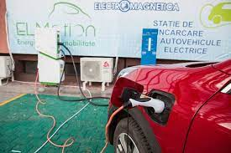
Development of a charging hub for electric vehicles
ELECTROMAGNETICA developed in its premises a charging hub with 9 Fast Charge AC + DC stations and 21 AC charging stations for electric vehicles.
This project has several advantages, from the supply of electrical power for electric vehicles to the validation of technical solutions for both hardware and software.

C. Low voltage electrical switchgear
The production of low voltage electrical switchgear (for ABB Italy) represents an element of continuity and stability in the production intended for export. In 2020, however, it decreased slightly (by -9.3 %).
Electrical switchgear accounted for the highest share in export in 2020, i.e., 59%.
Most of this activity is automated and robotised.

► ELECTRICITY PRODUCTION AND SUPPLY

A. Production of electricity from renewable sources
Energy production is a field regulated by ANRE, the company holding the licence of producer since 2007.
ELECTROMAGNETICA SA owns and operates 10 micro-hydro power plants in the Suceava River basin, which have been modernized and automated over time.
In 2020, energy production in its micro-hydro power plants decreased (by -18.7%) compared to the previous year, due to a weak rainwater regime, reaching 11,151 MWh.
Approximately 30% of the need of green certificates required to supply energy were assured from own energy production.
The number of green certificates (GCs) granted in 2020 was 25,001.

B. Electricity supply activity
The activity of energy supply, operating within the framework regulated by ANRE, constitutes together with the energy production the segment of licensed activities.
ELECTROMAGNETICA SA has been an authorized supplier since 2001; in 2013 the license was renewed for another 10 years, under the provisions of the new Energy Law (Law no. 123/2012).
A special focus was set on risk management through a pre-contractual analysis of consumers and sustained actions aimed at clients who exceeded the payment deadline (including disconnection notifications), so that the overdue amounts were very small.
A significant part of the green certificate requirements for the entire portfolio of supply customers was also covered in 2020 as well by the certificates obtained for the energy produced by the company’s own micro-hydro power plants.
The trend in electricity supply over the last 4 years is shown in the following chart:
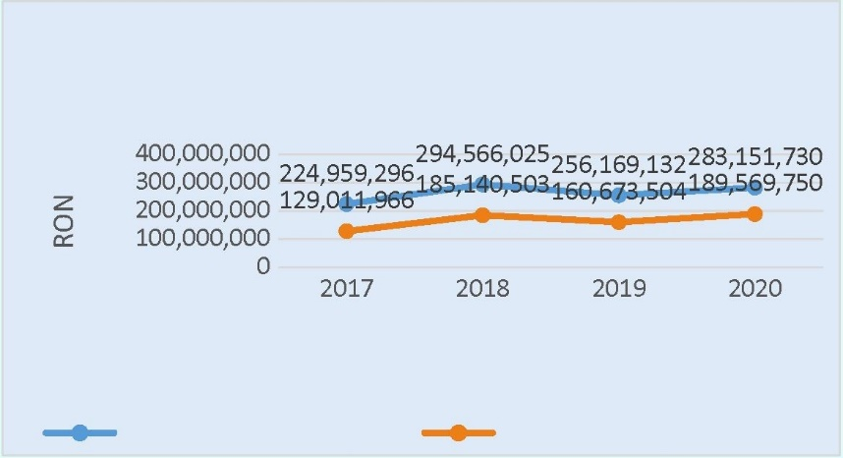
Company turnover
Electricity supply
Evolution of energy supply turnover vs. total turnover

► REAL ESTATE RENTING AND DEVELOPMENT

Rental of premises and provision of utilities
Electromagnetica manages approximately 33,000 square meters of premises to be leased in Bucharest and 3,500 square meters in Varteju, Ilfov county.
At the end of 2020, the average occupancy rate was 94.34% for the headquarters in Calea Rahovei 266-268.
For the premises in Varteju commune (Magurele), the occupancy rate was 94.43%.

At 31 December 2020, the structure of rentable premises by their destination was as follows:
Item no. | Destination of premises to be rented at the headquarters | Weight % | Destination of premises to be rented in Varteju | Weight %
1 | Offices | 44.51 | Offices | 3.38
2 | Warehouses | 25.97 | Warehouses | 33.84
3 | Production | 14.17 | Production | 54.23
4 | Provision of services | 15.35 | Provision of services | 8.65
The activity related to the provision of utilities saw an increase of approximately 7.09% as compared to the previous year, as a result of the increase in the rentable premises and of the favourable evolution of the average EUR/RON rate of exchange as compared to the year 2019. Compared to the previous year, the share of rentable premises for offices, service provision and production facilities remained relatively at the same level.
The challenges in terms of rental income for the following period are related to the risk of a reduction in the activities of some tenants or their migration to other areas, as required by the evolution of their operations.
The high level of delivery on the office market, in particular the offer of premises for modern offices, will exceed the demand for offices in Bucharest, thus leading to a possible decrease in the occupancy rate, especially for older buildings or premises located in difficult-to-access areas.
In order to make better use of the real estate assets outside the headquarters, feasibility studies have been drawn up for a part of the land in Bucharest and Ilfov County, envisaging own investments in the near future or in the medium and long term.

► OTHER DEVELOPED PRODUCTS AND ACTIVITIES

A. Plastic injection and moulds
ELECTROMAGNETICA SA benefits from a wide range of technologies, which enables the Company to manufacture plastic injection moulded subassemblies for both the internal market and export.
The Company currently owns 24 injection machines, most manufactured products being auto parts.
The company produces plastic subassemblies for DRAEXLMAIER ROMANIA, which in turn supplies products for BMW and MASERATI.
Another important client in this production segment is MAKITA ROMANIA, which has considerably increased its orders for boxes, cases and various plastic parts and subassemblies for drilling and cutting machines.
The production of plastic injection moulded subassemblies and moulds increased by 44.5% in 2020 as compared to the previous year.
This group of products has the second largest share of the exports of the Company, i.e., 22.6% of total exports.
The production of plastic injection moulded subassemblies also benefits from the on-site manufacture and repair of the moulds.

B. Railway traffic safety equipment
The National Railway Company CFR SA, the railway infrastructure manager in our country, is the final beneficiary of these services, the orders for railway traffic safety elements being placed with ELECTROMAGNETICA SA by private operators that provide maintenance services for the railway infrastructure, such as ALSTOM and SIEMENS.
Consequently, orders are largely dependent on the pace of upgrading the railway infrastructure, which caused the sales of railway traffic safety-related elements in the year 2020 to decrease by 9% as compared to 2019.

IV. THE VISION OF ELECTROMAGNETICA SA ON SUSTAINABILITY AND SUSTAINABLE DEVELOPMENT

The strategy for sustainability and sustainable development of ELECTROMAGNETICA SA relies on the fact that Romania joined the leaders of the 193 UN Member States at the Summit on Development in September 2015 and adopted the 2030 Agenda for Sustainable Development, a comprehensive global development action program of a universal nature, promoting a balance between the three dimensions of sustainable development– economic, social and environmental.
For the first time, actions are equally aimed at developed and developing states.
The 2030 Agenda includes the 17 Sustainable Development Goals (SDGs), which are informally referred to collectively as Global Targets. Through the Global Targets, an ambitious agenda for action for the next 15 years is set to eradicate extreme poverty, combat inequalities and injustice and protect the planet by 2030:
SDG 1 – Eradicate poverty – End poverty in all its forms everywhere.
SDG 2 - Zero hunger – End hunger, achieve food security and improved nutrition and promote sustainable agriculture.
SDG 3 – Health and well-being – Ensure healthy lives and promote well-being for all at all ages.
SDG 4 - Quality education – Ensure inclusive and equitable quality education and promote lifelong learning opportunities for all.
SDG 5 – Gender equality – Achieve gender equality and empower all women and girls.
SDG 6 - Clean water and sanitation – Ensure availability and sustainable management of water and sanitation for all.
SDG 7 - Clean and affordable energy – Ensure access to affordable, reliable, sustainable and modern energy for all.
SDG 8 - Decent work and economic growth – Promote sustained, inclusive and sustainable economic growth, full and productive employment and decent work for all.
SDG 9 - Industry, innovation and infrastructure – Build resilient infrastructure, promote inclusive and sustainable industrialization and foster innovation.
SDG 10 – Reduce inequality – Reduce inequality within and among countries.
SDG 11 – Sustainable cities and communities – Make cities and human settlements inclusive, safe, resilient and sustainable.
SDG 12 – Responsible consumption and production – Ensure sustainable consumption and production patterns.
SDG 13 - Climate action – Take urgent action to combat climate change and its impacts.
SDG 14 - Aquatic life – Conserve and sustainably use oceans, seas and marine resources for sustainable development.
SDG 15 - Land life – Protect, restore and promote sustainable use of terrestrial ecosystems, sustainably manage forests, combat desertification, and halt and reverse land degradation and halt biodiversity loss.
SDG 16 - Peace, justice and efficient institutions – Promote peaceful and inclusive societies for sustainable development, provide access to justice for all and build effective, accountable and inclusive institutions at all levels.
SDG 17 - Partnerships to achieve goals – Strengthen the means of implementation and revitalize the Global Partnership for Sustainable Development.

At the same time, our sustainability and sustainable development strategy relies on respect for the principles of the United Nations Global Compact. These principles require businesses to accept, support and apply, within their sphere of influence, a set of fundamental values in the areas of human rights, essential labour standards, the environment and the fight against corruption, which they integrate voluntarily in their business operations:
UN Global Compact Principle 1 – HUMAN RIGHTS: Businesses should support and respect the protection of internationally proclaimed human rights
UN Global Compact Principle 2 – HUMAN RIGHTS: Businesses should make sure that they are not complicit in human rights abuses.
UN Global Compact Principle 3 – LABOUR: Businesses should uphold freedom of association and the effective recognition of the right to collective bargaining.
UN Global Compact Principle 4 – LABOUR: Businesses should uphold the elimination of all forms of forced and compulsory labour.
UN Global Compact Principle 5 – LABOUR: Businesses should uphold the effective abolition of child labour.
UN Global Compact Principle 6 – LABOUR: Businesses should uphold the elimination of discrimination in respect of employment and occupation.
UN Global Compact Principle 7 - ENVIRONMENT: Businesses should support a precautionary approach to environmental challenges.
UN Global Compact Principle 8 – ENVIRONMENT: Businesses should undertake initiatives to promote greater environmental responsibility.
UN Global Compact Principle 9 – ENVIRONMENT: Businesses should encourage the development and diffusion of environmentally friendly technologies.
UN Global Compact Principle 10 – ANTI-CORRUPTION: Businesses should work against corruption in all its forms, including extortion and bribery.

ELECTROMAGNETICA SA aims through its activities - which include the technologies used, the human resources involved and the quality and environmental standards we uphold - as well as through the products offered to our customers, at a permanent growth of our contribution to the achievement of the Sustainable Development Goals and the UN Global Compact Principles.

According to the vision of ELECTROMAGNETICA SA, sustainability is achieved separately, for each of the three pillars: economic, social and environmental, but in particular by ensuring an optimal mix between these, as outlined below:


environment
SUSTAINABLE,
SUSTAINABLE DEVELPMENT
economic
social

The sustainability and sustainable development area is represented by the intersection of the three pillars

In our vision, which is aligned with the European and global vision, sustainability and sustainable development can only be achieved by an optimal mix of the three elements - economic, social, environmental -, our strategy being to maintain the balance between these, in the sense that it is not advantageous in the long term to develop just one of the three pillars, but all, to the largest extent possible.
For example, focusing only on economic development is likely to impede societal elements (even if it increases technological comfort, social relationships will be destroyed) and people (including managerial focus on productive tasks, affecting employment relationships and the stability/continuity of employees) and to have disastrous effects on the environment (from the destruction of natural habitats to the generation of greenhouse effects impacting on the climate and extreme weather events).
Similarly, focusing only on actions aimed at protecting the environment will lead to economic stagnation, with negative effects reflected in the absence of technological progress and the impairment of people’s life and comfort, social relationships being at great risk of deterioration.
At the same time, focusing only on the social factor leads, over time, to the impoverishment of companies and states, these negative effects resulting in the impairment of well-being and human relationships, implicitly, and damage to the environment by the failure to take the adequate protection measures, which affects the entire planet.

A. Sustainability of the economic pillar

ELECTROMAGNETICA SA benefits from various technologies and equipment that make possible to obtain a diversified listing of products.

The weight of the main groups of products within the turnover related to the production (except for services) for 2020 is the following:
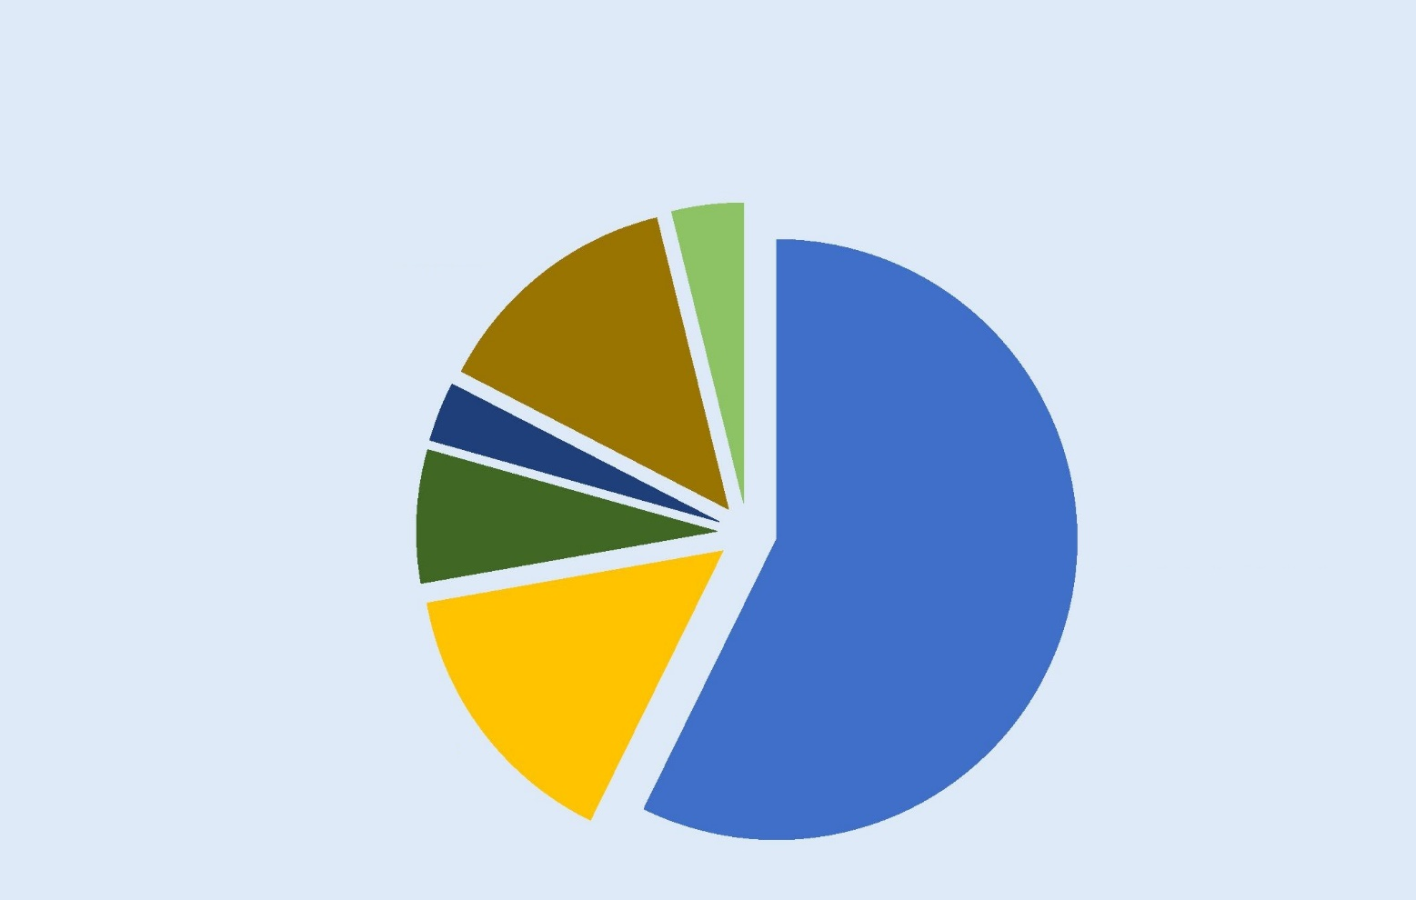
Electricity production 3.84%
Electrical switchgear 13.57%
Various (including moulds)
3.21%
CFR traffic safety elements
7.16%
Plastic injection
and moulds
14.95%
Lighting fixtures and charging stations 57.27%
Production structure in 2020

As the above chart shows, in 2020, ELECTROMAGNETICA focused mainly on the operations that promote green energy and its efficient and sustainable use.
This strategy of our company is in line with that of the European Union, which proposed in July 2021 a package of measures to reach the goal of a reduction by 55% in greenhouse gas emissions compared to 1990 and to achieve climate neutrality in 2050.
Among these are the ban applicable as of 2035 on the marketing of new diesel and petrol cars - therefore an adequate infrastructure for charging electric cars will be needed, the increased use of renewable energy sources (with the target that 40% of EU energy be produced from renewable sources by 2030, which is consistent with the focus of our company on electricity generation by using micro-hydro power plants, simultaneous with the reduction of energy consumption – therefore our strategy of delivering LED devices for street and interior lighting is adapted to this aim - etc.
In relation to the current structure of the production of ELECTROMAGNETICA SA and as translated into our strategy for the future, we aim to achieve business sustainability by directing our research-development-design and manufacturing activities to, and covering the demand in the related markets for those products and equipment that will see an increasing trend in consumer interest while being environmentally friendly:
► PRODUCTS AND SERVICES TO INCREASE ENERGY EFFICIENCY - LED lighting bodies, systems and solutions
Compared to the growth already recorded, specialists estimate an increase in the global market for industrial lighting fixtures by an annual rate of 4.5% in the following period, i.e. 2021-2026.
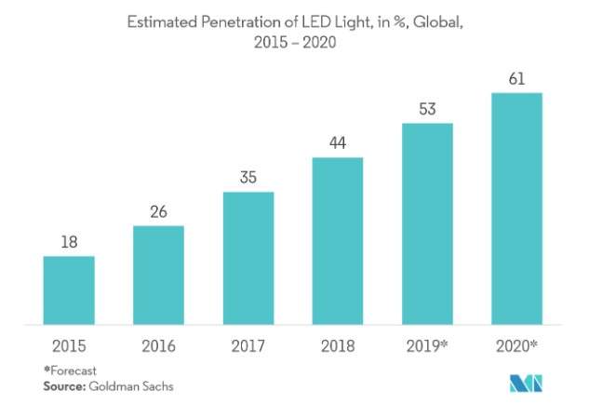

The forecast of the LED products growth in the next few years
This increase is driven by the longevity, energy efficiency, low operational/maintenance costs and high return on investment offered by LED products.

► Charging stations for electric vehicles
Given the accelerated increase in the number of electric or plug-in hybrid vehicles in the following period, in conjunction with the precarious condition of the current charging infrastructure, which is insufficient in relation to current and forecast needs, we expect a high demand of charging stations of the kind developed by ELECTROMAGNETICA SA.
In this way we aim to follow the world trend in energy consumption, to promote technologies that will ensure the protection of the environment, but also to ensure that we will have a market for our products in the future and that our current investments will be put to better use in the future, on the short-term, but especially on the medium and long-term.
The forecast growth of the electric vehicle (EV) fleet over the following years is shown below:
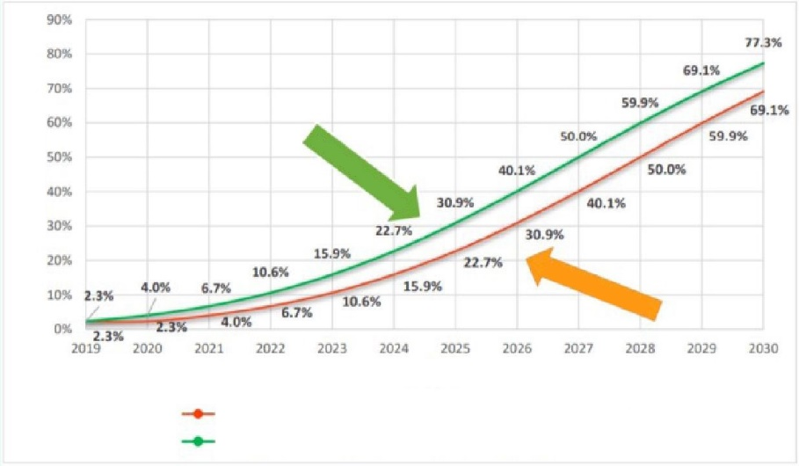
The number of EV at the end of 2019 remains the same at the end of 2020
The number of EV at the end of 2019 doubles by the end of 2020

Time (years)
Adoption rate (%)
Pessimistic scenario
Optimistic scenario
The forecast growth of the electric car fleet in the coming years

Consequently, considering this trend in the segment of electric vehicle charging stations, ELECTROMAGNETICA SA will participate in 2021 both in the ELECTRIC UP program financed by the Ministry of Energy, and in the program financed by the Environment Fund Agency regarding the installation of 50 kW + 22 kW stations in municipalities and tourist resorts.
In 2021, we will continue the development of the 100kW Fast Charger station and the tests with the alternative charging controller.
The 30 KW rectifier will be developed based on our own concept, as an alternative to the imported solution.
As regards the software, we will implement features for vehicle fleets, for integration with other systems (Plugshare) as well as for the integration with Smart City platforms.

► Production of electricity from renewable sources
The total energy consumption on the world scale is expected to increase rapidly in the next period, both on the short and medium term, and on the long term.
The population-energy correlation and the evolution of these indicators on a global scale is shown below.
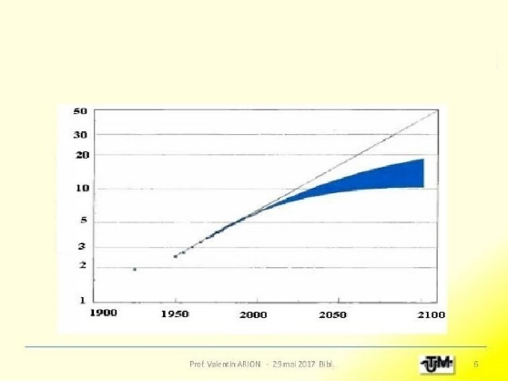
YEAR
Billions of people
1.9% per year
“Population-energy“ correlation,
The demographic and energy consumption evolution on a global scale
Demographic and energy consumption trends worldwide

In conjunction with this trend, the general principles of sustainability and sustainable development call for emphasis on renewable energy production.
In this respect, the acquisition by ELECTROMAGNETICA of the 10 micro-hydro power plants and the production of hydro power in these plants - which currently total an installed power of 5.5 megawatts - proves to be a sustainable action on the short, medium and long term.

By bringing together the actions undertaken by our company, we believe that ELECTROMAGNETICA SA contributes to the United Nations Global Sustainable Development Goals (SDGs) and is aligned to the UN Global Compact Principles through the sustainability of its economic pillar, as follows:
SDG 7 - Clean and affordable energy: Ensure access to affordable, reliable, sustainable and modern energy for all.
SDG 8 - Decent work and economic growth: Promote sustained, inclusive and sustainable economic growth, full and productive employment and decent work for all.
SDG 9 – Industry, Innovation and infrastructure: Build resilient infrastructure, promote inclusive and sustainable industrialization and foster innovation.
SDG 12 – Responsible consumption and production: Ensure sustainable consumption and production patterns.
SDG 13 – Climate action: Take urgent action to combat climate change and its impacts.
SDG 15 – Land life: Protect, restore and promote sustainable use of terrestrial ecosystems, sustainably manage forests, combat desertification, and halt and reverse land degradation and halt biodiversity loss.

UN Global Compact Principle 9 – ENVIRONMENT: Businesses should encourage the development and diffusion of environmentally friendly technologies.

B. Sustainability of the social pillar
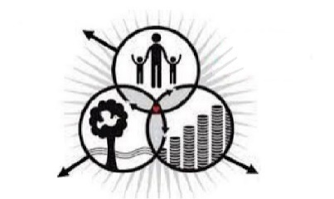
ELECTROMAGNETICA SA considers that its most important resource is the human resource; our first priority is PEOPLE as employees and representatives of our company.
Social
welfare
Sustainable society
Healthy environment
Strong economy

We want to build and ensure a working environment focused on integrity, professionalism, motivation and satisfaction, a climate that would be the guarantee of our success in the future: satisfied and healthy employees, strong company!

We are aware that the entire behaviour of each employee, whether directly or not in connection with the performance of their duties, can influence the success, as well as the reputation of ELECTROMAGNETICA SA.
At the level of internal employment relationships, we strongly discourage any form of intimidation by language, attitudes or gestures and we do not accept discrimination; we grant equal opportunities to our current or potential employees.
In our relations with partners and stakeholders, we always act in accordance with the law and business ethics. We do not accept corruption, evasion, monopolization or intimidation in our activity.
Our aim is to put in place mechanisms to detect and eliminate cases of breaches of ethical and deontological rules. We therefore encourage any employee, customer, supplier or subcontractor to report the unethical behaviour of any executive employee or manager at all levels of ELECTROMAGNETICA SA.
In this context, we implemented a CODE OF ETHICS, which is known and acknowledged by all the employees of ELECTROMAGNETICA SA. This CODE OF ETHICS is consistent with the values assumed and publicly promoted by our company, according to which business ethics is the foundation of our commercial relations, characterised by honesty, integrity, communication and mutual trust.
The aim is to consolidate an appropriate working environment, while promoting the image and reputation of ELECTROMAGNETICA SA in the business environment in which it operates, as well as to strengthen investors' confidence in the viability of the company's actions.

The general principles governing the professional conduct of the employees of ELECTROMAGNETICA SA are as follows:
respect for the supremacy of the Constitution and the law
in their actions, the employees of ELECTROMAGNETICA SA obey the Constitution and the laws of the country, in accordance with their respective duties

loyalty to ELECTROMAGNETICA SA
the employees must protect the reputation of ELECTROMAGNETICA SA and refrain from any actions that could harm the image or interests of the company

honesty and fairness
in the exercise of their functions and in the performance of their duties, employees must show good faith, honesty and fairness

confidentiality
under this legal obligation, the employees of ELECTROMAGNETICA SA must ensure and preserve the confidentiality of information obtained in the course or as a result of the performance of their duties

openness and transparency
any activities of public interest carried out by the employees of ELECTROMAGNETICA SA are public in accordance with the rules applicable to the companies listed on the stock exchange

impartiality and non-discrimination
in the performance of their duties, the employees of ELECTROMAGNETICA SA are required to have an objective and neutral attitude in relation any political, economic, religious or other interest

independence
the employees of ELECTROMAGNETICA SA must act independently from any interest of the participants in the market in which they carry out their professional activity and must neither seek nor take direct instructions from any public or private entity, except for the institutional relations conducted by official means

integrity
the employees of ELECTROMAGNETICA SA must perform their obligations and duties in the job description honestly and with the utmost fairness, in a professional, impartial and independent manner, without any abuse

freedom of thought and expression
in any event, the employees of ELECTROMAGNETICA SA must express and base their opinions with respect for the freedom of opinion of their interlocutors

professionalism
the employees of ELECTROMAGNETICA SA must perform their professional duties with responsibility, competence, efficiency, fairness and thoroughness

the employees of ELECTROMAGNETICA SA are instructed to avoid any potential situations that fall within the definition of conflicts of interest
Transactions and business relationships with the parties involved are concluded on non-preferential terms and are negotiated by executive employees or members of management not related to the parties involved.
Annually, the directors and officers of the Company submit statements on honour regarding conflicts of interest and the non-performance of competitive activities.

As the company is listed on the stock exchange, the dissemination of information is carried out under the ASF rules, in compliance with the transparency rules and on a non-discriminatory basis.
ELECTROMAGNETICA SA publishes the financial reports in accordance with the generally accepted accounting principles and the legal regulations in force. These reports contain the financial position and result of the company, thereby ensuring that all interested parties are simultaneously provided with accurate and complete information.

An essential requirement for the employees of ELECTROMAGNETICA SA is to protect the business secrets and the information about the company and its customers or partners.
The employees of the company are bound to observe the professional secrecy and the confidentiality of all the operations of the company, of the data and information relating to the past, present and future of the company (strategic plans) and regarding the significant shareholders of the company, which information, by its content, is likely to have adverse effects on their own reputation and interests or on those of ELECTROMAGNETICA SA; these obligations survive after the termination of their contract.

The employees of ELECTROMAGNETICA SA are aware that their entire behaviour, both during and outside working hours or outside the premises of the company, may have positive or negative effects on the reputation of the company.
By accepting and promoting the moral responsibility imperatives, we can secure the trust of our customers, shareholders and business partners, communities and every interested external party and permanently improve the reputation of the company.

As regards the participation of the management in social matters, we aim to maintain a constructive cooperation relationship with the employees' organizations and other interested parties by:

☼ support for a constructive trade union activity and conclusion of a collective bargaining agreement specific to the employees of ELECTROMAGNETICA SA;
☼ permanent communication regarding all major aspects of the development of the organisation and business with the trade union organisations, considering the employees as a third party interested in the success of the business;
☼ establishing and implementing ways of helping people at a disadvantage and/or in special family situations;
☼ establishing and implementing different facilities for all employees, depending on the organisation’s potential and identified needs;
☼ monitoring the health of employees by performing regular specialised examinations (including, without limitation, free of charge, a complete set of blood analyses);
☼ support for employees and their families when they are confronted with difficult health issues;
☼ coverage of 50% of the costs of treatment in health spas for the employees (for certain categories);
☼ granting meal vouchers (for certain categories of employees);
☼ In 2020 and onwards, in relation to the COVID 19 pandemic, depending on its evolution and the measures recommended by the State authorities and/or medical specialists, ELECTROMAGNETICA SA considered and continues to consider the protection of employees as a first priority both by preventive measures - free of charge provision of protective materials such as masks, disinfecting solutions, etc. -and by PCR testing when there were/are suspicions of infection; in confirmed cases, extended testing was/will be conducted on all employees working in the same premises.
The persons tested positive were provided with first response counselling by the occupational physician, recommending in all cases isolation at home and contact with the family physician and the DSP.

ELECTROMAGNETICA SA ensures equal opportunities for all its employees, current or potential, by:
♦ recruitment/promotion of staff in a transparent manner, taking into account the necessary professional competence and experience and the integrity of candidates;
♦ ensuring conditions for continuous training and improvement in their professions, but also for the protection of the environment and health and safety at work;
♦ evaluation of their activity and skills only on the basis of objective, sustainable, measurable, fit-for-purpose performance criteria, monitored consistently and communicated transparently to all employees;
♦ the creation of optimum working conditions to stabilize personnel;
♦ the trade union organization has a degree of representation of over 73% of the staff, is a party to the negotiation of the collective agreement and is a partner in the implementation of social and personnel policies.

In order to provide employees and tenants with additional facilities and the best conditions for their activities, the premises of ELECTROMAGNETICA BUSINESS PARK include a cafeteria, a fast-food area, two small food shops and a green recreation area (the English Garden).

ELECTROMAGNETICA SA supports the access of women to management positions, ensuring equal opportunities for promotion. The share of women at the end of 2020 was:
42.9 % in the board of directors
25% in management positions
37.2 % in the middle-management area (heads of departments/services)
45.8 % of the total number of employees.

Involvement in the community
ELECTROMAGNETICA SA considers that, regardless of its size, a company has an impact (economic, social and environmental) on the community in which it operates, and is able to accentuate the vulnerabilities it faces or even contribute to the creation of others.
For this reason, we aim to engage in the community, including by investing in the communities in which our subsidiaries and sites carry out their activities or which are affected by them, trying to demonstrate that we are aware of the need to participate in the social and economic development of those areas.
By applying good practices of corporate governance and transparency, we inform the public about the social responsibility activities in which we are involved.

☼ we support disadvantaged people and/or communities through sponsorship;

☼ at the request of the employees of ELECTROMAGNETICA SA, we direct the 2% share of the income tax paid by employees to the Red Cross and/or NGOs.

☼ given that, for many years, there has been a crisis of places in kindergartens in Bucharest, ELECTROMAGNETICA SA has concluded several years ago an agreement with the Ion Barbu High School for the functioning of the Electromagnetica kindergarten in company-owned premises.
☼ in 2020, a wing of the building was modernized to host a new kindergarten.

By bringing together the actions undertaken by our company, we believe that ELECTROMAGNETICA SA contributes to the United Nations Global Sustainable Development Goals (SDGs) and is aligned to the UN Global Compact Principles through the sustainability of its social pillar, as follows:
SDG 1 – Eradicate poverty: End poverty in all its forms everywhere.
SDG 3 – Health and well-being: Ensure healthy lives and promote well-being for all at all ages.
SDG 4 – Quality education: Ensure inclusive and equitable quality education and promote lifelong learning opportunities for all.
SDG 5 – Gender equality: Achieve gender equality and empower all women and girls.
SDG 8 - Decent work and economic growth: Promote sustained, inclusive and sustainable economic growth, full and productive employment and decent work for all.
SDG 10 – Reduced inequality: Reduce inequality within and among countries.
SDG 11 – Sustainable cities and communities: Make cities and human settlements inclusive, safe, resilient and sustainable.
SDG 12 – Responsible consumption and production: Ensure sustainable consumption and production patterns.
SDG 17 – Partnerships to achieve goals: Strengthen the means of implementation and revitalize the Global Partnership for Sustainable Development.

UN Global Compact Principle 1 – HUMAN RIGHTS: Businesses should support and respect the protection of internationally proclaimed human rights
UN Global Compact Principle 2 – HUMAN RIGHTS: Businesses should make sure that they are not complicit in human rights abuses.
UN Global Compact Principle 3 – LABOUR: Businesses should uphold freedom of association and the effective recognition of the right to collective bargaining.
UN Global Compact Principle 4 – LABOUR: Businesses should uphold the elimination of all forms of forced and compulsory labour.
UN Global Compact Principle 6 – LABOUR: Businesses should uphold the elimination of discrimination in respect of employment and occupation.
UN Global Compact Principle 10 – ANTI-CORRUPTION: Businesses should work against corruption in all its forms, including extortion and bribery.

C. Sustainability of the environmental pillar


ELECTROMAGNETICA SA pays particular attention to the environmental protection pillar of the sustainability concept.
In fact, this focus is consistent with the high weight of environmental matters in the United Nations Global Sustainable Development Goals (SDGs) and the UN Global Compact Principles, most people, managers/companies and NGOs considering this pillar to be the most important.

Our strategy is to implement environmental protection policies, both in terms of the products that we place on the market, focused on green energy, cost savings, high efficiency and minor impact on the quality of the environment, and in terms of our productive activities, throughout the entire process, so that pollution or generated waste do not affect the environmental quality indicators.
In applying this strategy, we are starting from the activities we carry out, the way our products are made and the markets in which we are selling these products, and the way in which they are used by the final beneficiaries.
We thus put into operation the principles of sustainability and sustainable development of the environmental pillar in all economic phases, from design, production and waste disposal, to the use of our products sold to customers.

As for the products which we place on the market, reminding the characteristics of the economic activities of ELECTROMAGNETICA SA - as described in detail in Chapters III. 6.c and IV -, we highlight:
☼ our intention to promote the production of renewable energy, its use in the supply activities and the capitalisation of green certificates.
☼ we encourage the use of electric vehicles by our attempt to increase our contribution to the development of the charging infrastructure for these vehicles, as prerequisites for protecting the environment.
☼ following the same trend of efficient and economical use of energy resources, our strategy is also aimed at placing on the relevant market, in a wide range targeted at both natural and legal persons, companies or local administrations, LED lighting fixtures for interior lighting, industrial buildings and street lighting. We consider the high energy efficiency of this equipment as well as its low environmental impact, as compared to traditional lighting.

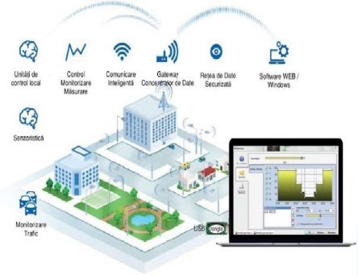
In 2020, we continued the implementation of ENERGSys in public lighting systems. Thus, the purpose of this application is to manage the power-on points, to operate the lighting system in automatic mode (following a pre-set schedule) or in manual mode (locally or remotely), as well as to monitor energy consumption, the condition of the network and the quality of electricity.

At the same time, the software system has been developed to help meet the current requirements regarding energy market liberalization, ensuring the generation of reports and load curves at 15-minute intervals. In October 2020, a contract was signed with Electrica to support the operation of the system for a period of one year, which includes maintenance operations, as well as software development.

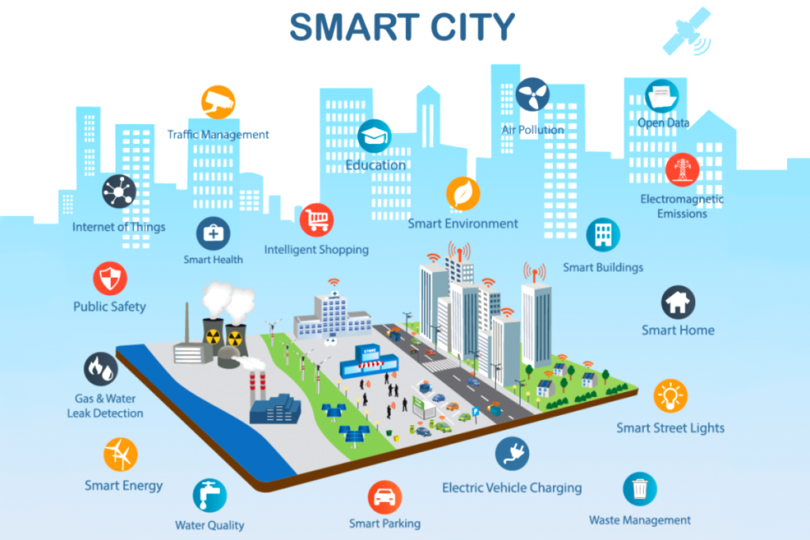
For 2021, the development of a new data concentrator for ENERGSys is planned, to provide wider connectivity and to be used mainly in Smart City projects.
For this purpose, we aim that the new type of concentrator, besides reading electricity meters and providing the ON/OFF control function, be able read sensors such as air quality sensors, temperature sensors, humidity sensors, etc.


At the same time, for 2021, another development perspective is the integration of the current applications developed by ELECTROMAGNETICA SA into the SmartCity platform.
This would involve taking over the information on electric vehicle charging stations from the ELMotion platform.

As regards the performance of the entire production process, the company fully complies with the requirements of the Integrated Management System and continuously improves its effectiveness by establishing, monitoring and reviewing our goals.
As a responsible organisation, ELECTROMAGNETICA SA aims to secure the trust of its partners and considers the environment as an important, decisive and integrated element of the society's culture.

The company holds all the environmental permits required for its business and has in place an Environmental Management System compliant with SR EN ISO 14001:2015.

The company does not carry out activities with a significant negative impact on the environment and there are no litigations related to breaches of the legislation on environmental protection.

This particular attention to environmental protection is also a requirement that we impose on our own staff, as well as on our contractors and suppliers: active participation through the implementation of all the relevant regulations and programs adopted.

The policy of the company in this area aims to:
- minimize the quantities of waste generated and manage waste safely when their generation cannot be avoided;
- reduce the consumption of natural resources;
- reduce the environmental impact associated with the activities and products of the company, both present and future, by gradually replacing technologies and raw materials with others with low environmental impact;
- design and develop eco-friendly and economical products which, during their lifetime, reduce the environmental footprint;
- have a positive influence, both upstream and downstream the supply chain of raw materials and product marketing, in terms of sustainable development;
- prevent the occurrence of emergency situations with environmental impact by establishing and implementing coherent and efficient measures to prevent major accidents involving dangerous substances, as well as to develop scenarios for prompt intervention preparation and to ensure resilience;
- adopt a preventive behaviour as regards environmental pollution in order to continuously improve environmental performance;
- continuously analyse risks and elements of major importance in processes;
- ensure an optimal working environment for employees in order to respect the right of interested parties to live in non-hazardous environmental conditions.

One of the research and development goals is to implement new energy-efficient and less polluting manufacturing technologies and launch new products with reduced environmental impact during their service life.

Production of electricity from renewable sources in micro-hydro power plants is considered to be an activity that has no significant environmental impact, but, in the exploitation of these power plants, we are careful to protect biodiversity in the areas that they influence.
Considering that certain low-power hydro power plants are located in the network of Natura 2000 protected areas, in order to obtain the environmental permit we have requested and obtained the custodian’s approval.


The ecological network “Natura 2000” – the European ecological network of protected natural areas – includes areas of special protection of aquatic fauna, determined in accordance with Directive 79/409/EEC on the conservation of wild birds, and special conservation areas designated by the European Commission, and in accordance with Directive 92/43/EEC on the conservation of natural habitats and of wild fauna and flora. Natura 2000 is not a system of strictly protected reserves. Human activities are only permitted to the extent they allow the conservation of the species or habitats

By bringing together the actions undertaken by our company, we believe that ELECTROMAGNETICA SA contributes to the United Nations Global Sustainable Development Goals (SDGs) and is aligned to the UN Global Compact Principles through the sustainability of its the environmental pillar, as follows:
SDG 3 – Health and well-being: Ensure healthy lives and promote well-being for all at all ages.
SDG 6 - Clean water and sanitation: Ensure availability and sustainable management of water and sanitation for all.
SDG 7 - Clean and affordable energy: Ensure access to affordable, reliable, sustainable and modern energy for all.
SDG 8 - Decent work and economic growth: Promote sustained, inclusive and sustainable economic growth, full and productive employment and decent work for all.
SDG 9 – Industry, Innovation and infrastructure: Build resilient infrastructure, promote inclusive and sustainable industrialization and foster innovation.
SDG 11 – Sustainable cities and communities: Make cities and human settlements inclusive, safe, resilient and sustainable.
SDG 12 – Responsible consumption and production: Ensure sustainable consumption and production patterns.
SDG 13 – Climate action: Take urgent action to combat climate change and its impacts.
SDG 15 – Land life: Protect, restore and promote sustainable use of terrestrial ecosystems, sustainably manage forests, combat desertification, and halt and reverse land degradation and halt biodiversity loss.
UN Global Compact Principle 7 – ENVIRONMENT: Businesses should support a precautionary approach to environmental challenges.
UN Global Compact Principle 8 – ENVIRONMENT: Businesses should undertake initiatives to promote greater environmental responsibility.
UN Global Compact Principle 9 – ENVIRONMENT: Businesses should encourage the development and diffusion of environmentally friendly technologies.
V. RISK MANAGEMENT IN PRIORITY AREAS

Risks, threats, vulnerabilities; definitions and methodology
THREAT: a factor with external origin, a circumstance or an event with the potential to have a negative impact by which competition-related interests, values or objectives are seriously affected.
VULNERABILITY: the intrinsic property of an element, system or organisation, materialised in a defect or weakness in its procedures, design or implementation, which can lead to an unexpected, undesirable event.
RISK: the possibility/likelihood (measured as probability or frequency) of a THREAT to exploit a VULNERABILITY in order to produce a serious adverse effect.

RISK ANALYSIS: involves the allocation to each risk of a pair of indicators: probability of occurrence and probable effect in the case of its materialisation; these indicators can be qualitatively or quantitatively evaluated, depending on the specific nature of the activities subject to risk analysis.
RISK TREATMENT: consists of actions taken at the level of internal factors, namely on vulnerabilities and/or the ability of the company to respond to external threats, in order to reduce the probability of risk occurrence or to mitigate the negative effects if the risk is materialised.

V.1. Economic risks
A. Commercial/financial risks
Foreign exchange risk:
The supply of materials is mostly done from imports, especially for the LED production, resulting in relatively high purchasing price dynamics.
Probability/effect analysis:
Medium probability and medium effect
Risk treatment:
As the probability of this risk cannot be controlled, action is taken on the effect of its materialisation in terms of foreign currency exchange, by correlating the payment schedule with that of foreign currency exchange, given that the company generally records cash-flow surpluses; in order to keep the products profitable, action has been taken to improve technological processes so that the reduction in production costs would at least partly compensate for the need to renegotiate/adjust sales prices


RISK 1

Equity risk:
Ensuring the capacity of the company to carry out its activities in good conditions, through the optimization of the capital structure (equity and debts).
Probability/effect analysis:
Medium probability and medium effect
Risk treatment:
To treat this risk, action is taken to minimize the probability of occurrence. The analysis of the capital structure is focused on the cost of capital and the risk associated to each category. In order to maintain an optimal capital structure and an appropriate indebtedness, in the last years the company has proposed an adequate dividend policy to its shareholders, which would ensure its own financing sources. The absence of financing sources can limit the development of the company on the market segments where sales are supported by commercial facilities offers.

RISK 2

Liquidity and cash flow risk
The company cash flow department requires forecasts on the liquidity reserve and maintaining the appropriate level of credit facilities in order to be able to prudently manage the liquidity and cash flow risks.
Probability/effect analysis:
medium probability and medium effect; this risk is closely related to the risks described above
Risk treatment:
The company has open credit lines and letters of bank guarantee within the limit of 40% from the total of fixed assets, less receivables, making possible for the company to honour its obligations in case of short-term cash deficits. At the same time, investments were limited to own sources of financing, priorities being set according to the current needs of ELECTROMAGNETICA SA, as well as by taking into account the most profitable and/or developing fields of activity.

RISK 3

Risk of default in relation to the sold services/products:
The risk that contract partners fail to pay in time the products/services supplied by our company, leading to financial losses for ELECTROMAGNETICA SA. Trade receivables derive from a wide range of customers operating in various fields of activity and different geographical areas.
Probability/effect analysis:
Medium probability and medium effect
Risk treatment:
In order to treat this risk, we are taking action both to minimise the probability of occurrence and to limit the negative effects for our company in case of materialisation. When possible and allowed by market practices, the company requests guarantees. The company applied pre-contractual due diligence policies in relation to its customers (RISCO and COFACE reports). Insurance policies were contracted for foreign market receivables.
In order to recover outstanding debts, the Legal Department issued orders for payment followed by court proceedings and then, as applicable, by enforcement. Most of these debts have been recovered or are going to be recovered. The company also had customers who entered the insolvency procedure or the composition procedure, but their weight is small.

RISK 4

Risk of sanctions imposed by the control authorities:
Our company publicly declares its intention to comply with the laws and regulations in all areas in which it operates; however, there is a risk that the state authorities identify unintentional punishable irregularities.
Probability/effect analysis:
low probability and medium/undetermined effect
Risk treatment:
In order to treat this risk, we are taking action both to minimise the probability of occurrence and to limit the negative effects for our company in case of materialisation. This includes monitoring of legislative amendments and informing peers, participation in courses and seminars (labour law, competition law, GDPR - personal data protection, risk management and corporate governance, etc.) and, not in the least, trainings on compliance for the employees involved in relevant activities.
For example, in terms of competition, in the first part of 2021, the Competition Compliance Manual was developed, approved by the Board of Directors and later acknowledged by all the employees in the Sales, Procurement and Production/Supply Departments.
As regards the actions aimed at reducing negative effects, the company is prepared to take action in the court, through its Legal Department, against the sanctions it considers to have been incorrectly applied, a relevant example being the appeals filed by ELECTROMAGNETICA SA in the cases having as object the annulment of the Competition Council Decisions no. 82/2015 and no. 77/2017 and of the fines related thereto (with hearing dates set in 2021 at the High Court of Cassation and Justice). As these fines were forecast in the financial years concerned, there is only the prospect of improving the financial situation by a favourable solution.

RISK 5

B. Operational risks
Risk of failure to provide the forecast flow of electricity from micro-hydro power plants:
This risk can be caused by water flows below the expected ones, in case of drought or disruptions with natural (floods) or human (unauthorized intrusions) causes.
Probability/effect analysis:
medium probability and medium effect;
Risk treatment:
In order to treat this risk, we are taking action both to minimise the probability of occurrence and to limit the negative effects for our company in case of materialisation. The risk of unauthorized intrusions is treated preventively in the sense that a permanent monitoring of the perimeter of the micro-power plants is ensured, which is appropriately marked by fences, warning panels, night lighting and video cameras.
As regards the risk caused by water flows below the expected ones, given that the probability is beyond the control of ELECTROMAGNETICA SA, it can be treated by actions that mitigate its effects, related to electricity procurement policies targeted to a diversified portfolio.

RISK 1

Risk of deterioration in the economic efficiency of electricity supply contracts:
There is a risk of increase in the price at which our company purchases the electricity we are required to supply at the price set under bilateral contracts, which generates losses.
Among the markets in which the company operates, the energy market is the one with the highest price risk, taking into account the volatility and the significant price increase in recent years on the day-ahead market and the balancing market (large producers preferred to maximize their profits by selling large quantities on these markets to the detriment of long-term contracts), and the absence of long-term hedging mechanisms. The behaviour of electricity producers, namely to sell as much as possible on the spot market, can increase the price risk on this market.
Probability/effect analysis:
high probability and medium/high effect;
Risk treatment:
For the treatment/control of this risk, measures have been taken to minimize the probability of occurrence and to mitigate the negative effects occurred, such as limiting exposure on short-term contracts and outsourcing of balancing services.
Where there was a possibility of reviewing amicably the supply contracts, this was done in order to align prices with the market trend.

RISK 2

Risk of cheaper or higher-technology products entering the internal/external markets in which ELECTROMAGNETICA SA is active:
The entering on the internal or external market on which our company operates of similar products that are cheaper or use higher technology affects our market share, may lead to the loss of long-term customers and/or result in financial damage due to the reduction/loss of profit. This risk can occur in the markets of LED products, plastic injection parts or electric switchgear, which is a segment with a major share in exports. This risk can also occur in the segment of electric vehicle charging stations, which could jeopardize our strategy to develop partnerships with established operators that supply conventional fuels with the purpose to develop the charging infrastructure.
Probability/effect analysis:
medium probability and high effect;
Risk treatment:
In order to treat/control this risk, measures have been taken to minimize the probability of occurrence, in the sense that the R&D segment is constantly focusing on improving the technologies used to create/design the products in question, so that we maintain our competitiveness both in terms of price and technological progress.

RISK 3

Risk of placing on the market non-compliant or defective products:
The placing on the market of products which, after sale, in the process of operation, under warranty, present hidden defects or non-conformities with the technical characteristics stated in the package leaflets, whatever their nature or the market for which they are intended, is likely to diminish the trust of our long-term customers, lead to loss of market share and difficulties in identifying new customers for the products in question, but also to harm the image of the company in general.
Probability/effect analysis:
low probability and high effect;
Risk treatment:
In order to treat/control this risk, measures have been taken to minimize the probability of occurrence, in the sense that the suppliers of raw materials and materials necessary for the production and functioning of the other segments of the company are selected and evaluated annually on the basis of performance criteria which take into account the certifications obtained, the quality of products and the commercial conditions. At the same time, in the production process, we pay particular attention to the design, development, execution, marketing and after-sales support of the products and services we offer, so as to fully meet the requirements and expectations of our customers regarding quality, legal and regulatory requirements, and the reasonable expectations of the interested parties.

RISK 4

V. 2. Social risks

Risk of inability to attract/retain high quality human resources:
This risk materializes in difficulties in attracting highly qualified specialists or in retaining those who are already employed and prove to be skilled and reliable.
Probability/effect analysis:
average probability and high effect in terms of production achievement in the amount expected/required by the production and sales capacity and at a high quality level;
Risk treatment:
In order to treat/control this risk, measures have been taken to reduce the probability of occurrence, in the sense that the company grants employees a salary package consistent with the labour market, which is improved by providing non-salary entitlements such as health care, aids for special events, coverage of recovery and treatment costs, as well as the high level of working conditions (spaces for lunch and relaxation, kindergarten, etc., inside the premises of the company).

RISK 1

Risk of misconduct or violation of ethical conduct by the employees of the company:
Disciplinary offences are likely to endanger the entire activity of the company, result in nonconformities of the products and services subject sold by ELECTROMAGNETICA SA, while violations of ethics may have major repercussions on the working environment. In addition, any breach by any employee of the laws and rules on conflicts of interest is a major risk for the business and reputation of the company.
Probability/effect analysis:
low probability and major effect:
Risk treatment:
In order to treat this risk, the company acts both preventively, to reduce the probability of occurrence, and correctively, by not tolerating and strictly sanctioning any identified offences.
Thus, we pay special attention to the implementation of the annual education and professional training plan, the involvement of employees in the decision-making process by including in the board of directors a representative of the trade union, maintaining a budget dedicated tor solving special social situations and implementing an induction and integration plan for new employees.
All the employees of ELECTROMAGNETICA SA, whether in executive or managerial positions, must be aware that it is strictly forbidden to offer, promise or pay money or other benefits in order to obtain an undue advantage for business or personal purposes.
In order to ensure that all personnel, whether managerial or executive, is aware of our expectations and our definition of what is right and wrong in the behaviour of employees, we have developed and disseminated throughout the company the COMPETITION COMPLIANCE MANUAL, the CODE OF ETHICS and the REMUNERATION POLICY concerning management personnel, which includes a chapter on conflicts of interest.

RISK 2

Risk related to data protection and processing:
The company treats sensitive and privileged data that must be protected and disseminated in accordance with the transparency rules imposed by the fact that the company listed on the Bucharest Stock Exchange. The company also processes the personal data contained in the Register of Shareholders. This risk may also arise in relation to the accuracy of the statements, records and reports drawn up by the company.
Probability/effect analysis:
low probability, but high effect;
Risk treatment:
In order to treat/control this risk, we have taken measures to minimize the probability of occurrence, meaning that the Company respects the obligations provided in the General Data Protection Regulation (GDPR) – Regulation (EU) 2016/679, including the obligation to inform the data subjects at the time of collection of such data. Information is disseminated under the rules of the AFS, in compliance with the rules of transparency and non-discriminatory treatment.
The employees of the company are bound to observe the professional secrecy and the confidentiality of all the operations of the company, of the data and information relating to the past, present and future of the company (strategic plans), which information, by its content, is likely to have adverse effects on their own reputation and interests or on those of ELECTROMAGNETICA SA; these obligations survive the termination of their contracts. This obligation is stipulated in the individual employment contracts, as well as in the CODE OF ETHICS implemented by our company.

RISK 3

V. 3. Environmental risks
Risk of development and marketing of products with a major environmental impact:
The development and marketing of products with a major negative impact on the environment would contradict our policy of placing mainly environmental friendly products on the market and is not in line with the strategy adopted by our company, to contribute to the United Nations’ Global Sustainable Development Goals (SDGs), as stated in the previous chapter.
Probability/effect analysis:
low probability and high effect;
Risk treatment:
For the treatment/control of this risk, measures have been taken to minimize the probability of occurrence, in the sense that the company pays particular attention to this risk by implementing a quality system for our products and establishing the production strategy, while in the framework of R&D activities, our policy is to focus on environmentally friendly products, such as the production and distribution of energy from renewable resources, charging stations for electric vehicles, or LED products; for example, lighting fixtures based on LED products achieve at least 50% electricity savings compared to the traditional devices they replace.

RISK 1

Risk of unsafe/environmentally damaging waste management:
This risk arises when the waste resulting from productive activities is managed in a chaotic/inappropriate manner, without being stored and collected by a specialized operator according to well-defined procedures.
Probability/effect analysis:
low probability and high effect;
Risk treatment:
For the treatment/control of this risk, measures have been taken to minimize the probability of occurrence, in the sense that the company has in place procedures for waste management, selective collection and disposal by a specialized operator.

RISK 2

Risk of occurrence in the production process of accidents/emergency situations with a major impact on the environment:
Although we do not operate with dangerous substances, this risk must be taken into account in the production process, bearing in mind its major effects on the environment but also on the image of the company.
Probability/effect analysis:
low probability and high effect;
Risk treatment:
For the treatment/control of this risk, measures have been taken to minimize the probability of occurrence - by implementing a quality system , and to mitigate the negative effects occurred - by defining, training for and, if necessary, applying procedures for the management of emergency situations; ELECTROMAGNETICA SA is certified under the Environmental Management System for “design, development, production, marketing and service for: LED lighting fixtures, including for street lighting; electricity meters; parts and subassemblies made by plastic injection; parts and subassemblies made by die-stamping, cold plastic forming, mechanical processing; other products for electrical energy distribution and measurement technical installations; automotive subassemblies; plastic injection and cold plastic deformation tools; CFR relays; automation components and equipment; electric power plants (...)”, practically, the entire production of the company.

RISK 3

V. 4. Risks covered by insurance policies

Risk covered by insurance policies:
These risks include the risk of natural disasters, the risk of accidental damage, the risk of interruption of activity, the risk of recovery of debts of various debtors, the risk of injury to exposed employees, the protection of assets through insurance, the liability to third parties, the liability as producer, the professional liability for certain professions, the liability of directors, the risk of damage caused by floods to micro-hydro power plants, the risk of destruction of headquarters buildings caused by disasters.
Probability/effect analysis:
medium probability and medium effect;
Risk treatment:
In view of the fact that both the probability of these risks materialising and the destructive effects of their materialisation cannot be controlled at the level of our company, we decided to outsource these risks by entering into insurance policies for each of these risks.

RISK 1

VI. PARTNERSHIPS BY WHICH WE AIM TO DEVELOP OUR CAPACITY TO TACKLE THE PRESENT AND FUTURE CHALLENGES IN TERMS OF BUSINESS SUSTAINABILITY AND SUSTAINABLE DEVELOPMENT

☼ ELECTROMAGNETICA SA is a founding member of ARIR – the Romanian Investor Relations Association. Other ARIR members are Banca Transilvania, Hidroelectrica, Nuclearelectrica, Transelectrica, ALRO, BVB, Franklin Templeton Management.
In this capacity, the representatives of our company have actively participated in the meetings and conferences organized by ARIR, including the meetings with ASF.
Through these actions we aimed to improve our communication with investors as well as to be aware of the legislative changes expected on the capital market (European regulations and Romanian draft legislation).
According to the VEKTOR methodology, which quantifies the methods of communication with investors, created by ARIR together with BVB, our company managed to increase its score by almost 3 times as compared to the previous year - we have increased our score from 2 to 5.5 and we estimate that we will maintain the increasing trend of this score at the end of 2021.
☼ We are among the first companies that formed the competitive market of electricity suppliers; we are members of the Association of Electricity Suppliers in Romania – AFEER.
☼ We are members of the French Chamber of Commerce and Industry in Romania.
At the same time, ELECTROMAGNETICA SA is a member of the Romanian-German Chamber of Commerce and Industry, actively participating in meetings with the other members and present at various fairs and exhibitions organized by the Chamber.

VII. CONCLUSIONS

The strategy of our company is to contribute to the United Nations’ Global Sustainable Development Goals (SDGs) / to align to the United Global Compact Principles as a whole by ensuring the balance between the three pillars: economic, social and environmental. We rely on our employees and we consider them the foundation of our history of almost 100 years of specialized production of electrical and electronic equipment and we rely on them in implementing our strategy in the future.
As regards the products we offer on the market, in 2010, it turned out that they are on an upward trend in consumer preferences, while ensuring environmental protection.
As we have shown in Chapter IV, “The vision of ELECTROMAGNETICA SA on sustainability and sustainable development”, the trend of attractiveness of our products will continue to increase in 2021 and, further, in the medium and long term.
For example, LED lighting technology is preferred in all major projects that modernize lighting systems, so that the growth potential is preserved. Therefore, in order to increase competitiveness, it is necessary to increase the quality of our products to a level which will allow the warranty period to be extended and the costs of replacements to be reduced.
Similarly, according to our estimates, the market of vehicle charging stations will develop constantly, with more and more companies and local authorities having plans to purchase such stations, some purchases being stimulated by the above mentioned financing programs. To respond to this trend, our R&D activity focuses on improving the equipment we offer in the market, but also on a proactive attitude in the marketing and sales segment, to identify partnerships to increase our contribution to the development of the electric vehicles charging infrastructure.
ELECTROMAGNETICA SA will participate in 2021 both in the ELECTRIC UP program financed by the Ministry of Energy, and in the program financed by the Environment Fund Agency regarding the installation of 50 kW + 22 kW stations in municipalities and tourist resorts.
Last but not least, for 2021, our goal is to integrate the current applications developed by ELECTROMAGNETICA SA into “SmartCity” platforms. This includes the creation of access capabilities to management platforms for the integration of LED lighting, the integration of traffic, fog, rain, snow, air quality, temperature, humidity and wind sensors, data exchange with the ENERGSys measurement and remote management system, and retrieval of information about charging stations from the ELMotion platform.

Regarding communication, the management of ELECTROMAGNETICA SA considers that a high level of transparency together with investor protection is the key to the long-term support by shareholders of the company’s development strategy and the maximisation of the value of shares.
The strict observance of the applicable legal framework (Law no. 31/1990 on companies, republished; Law no. 297/2004 on capital market, as amended and supplemented; Law no. 24/2017 on issuers; ASF Regulation no. 5/2018 and the Code of Bucharest Stock Exchange) provides the conditions for compliance with internationally established corporate governance requirements.
ELECTROMAGNETICA SA prepares and publishes annually, on the BVB website and on its website, a financial/non-financial reporting schedule. The company prepares and disseminates regular and continuous information relevant to the investment decision, published on both its website and the BVB website (“ELMA” symbol).
We encourage communication with shareholders via the “Investors” section of our website, available at https://www.electromagnetica.ro/investitori-info/; for further information, investors can contact us by telephone at 021.404.21.31, by fax at 021.404.21.95 and by e-mail at: juridic@electromagnetica.ro.

https://www.eea.europa.eu/ro/semnale/semnale-de-mediu-2012/articole/calea-spre-o-durabilitate-globala
https://dexonline.ro/definitie/sustenabilitate
https://eur-lex.europa.eu/summary/glossary/sustainable_development.html?locale=ro
http://planningoradea.blogspot.com/2011/04/dezvoltare-durabila.html
https://home.kpmg/ro/ro/home/presa/comunicate-presa/2021/05/sustenabilitatea-element-cheie-afaceri.html
The GUIDE FOR RESPONSIBLE BUSINESS, draft, developed by the Romanian Investor Relations Association - ARIR – in collaboration with INNOVA Project Consulting;
The data is also available on the presentation page of ELECTROMAGNETICA SA;
https://www.mae.ro/node/35919;
https://www.linguee.com/english-romanian/translation/united+nations+global+compact.html;
https://infohale.ro/piata-corpurilor-de-iluminat-industrial-statistici-si-tendinte-pentru-2021-2026/
https://electromobilitate.com/prognoza-cresterii-parcului-auto-electric-in-urmatoarea-decada-episodul-ii/? utm_source=rss&utm_medium=rss&utm_campaign=prognoza-cresterii-parcului-auto-electric-in-urmatoarea-decada-episodul-ii
https://www.google.com/search?q=evolutia++energie+regenerabila+2021&tbm=isch&ved=2ahUKEwjzpPXM59_xAhWHgqQKHVPQAYAQ2-cCegQIABAA&oq=evolutia++energie+regenerabila+2021&gs_lcp=CgNpbWcQA1CWyRNYuM8TYLDUE2gAcAB4AIABU4gB-wKSAQE1mAEAoAEBqgELZ3dzLXdpei1pbWfAAQE&sclient=img&ei=C2ftYLPzNoeFkgXToIeACA&bih=1044&biw=1876&client=firefox-b-d#imgrc=xLmLLWouXQB5uM

